NEXT MILLIONAIRE

Project Report
A simple report about the quiz game, its features, and how it works
PROJECT REPORT SUBMISSION
Student name | ________________________________________
Student ID / Roll number | ________________________________________
Course / Class | ________________________________________
Submitted to | ________________________________________
Submission date | ________________________________________
ABOUT THIS PROJECT
Next Millionaire is a browser quiz game. Players answer general-knowledge questions, use lifelines, and try to reach the top prize. This report explains the main features in simple words and includes screenshots of the website.

1. Project Overview
Next Millionaire is a small website made with HTML, CSS, and JavaScript. It is designed to feel like a quiz-show game. Players can create a demo account, play questions, and see their best result on a leaderboard.

Project goals
- Make a quiz game that is easy to open and use in a web browser.
- Keep the pages connected with clear links between Home, Game, Login, Sign up, and Leaderboard.
- Separate the JavaScript into modules so each file has a clear job.
- Show how browser storage can keep demo account and score information on one device.

Tools and technologies
Technology | How it is used
HTML | Provides the page content, forms, buttons, and navigation.
CSS | Controls the colours, layout, and appearance on different screen sizes.
JavaScript modules | Runs the quiz and shares account, question, and sound features between files.
Browser storage | Keeps demo accounts and scores in this browser.
Web Audio | Creates the game sounds in the browser without separate audio downloads.

2. Main Features
- Account pages: create a demo account, log in, and log out.
- Home dashboard: shows the player greeting, best prize, rank, and player count.
- Quiz: 15 prize levels with four question choices per question. There are 60 question alternatives in total.
- Answer timer: the choices appear after a short reading pause, then the player has 20 seconds to answer.
- Retry: the player can retry one wrong answer once during a game.
- Three lifelines: 50:50, a simulated audience poll, and a question swap. Each can be used once per game, and only one lifeline can be used on each question.
- Prize progress: questions 5 and 10 are guaranteed prize points; players can also walk away between questions.
- Leaderboard: shows accounts and their best prize saved in the current browser.
- Sound controls: synthesized sound effects and studio ambience can be turned on or off.

3. How to Use the Website
- Open the project through a local web server, then open index.html in the browser.
- Create an account or log in. The account is only saved in the current browser.
- Choose ?Take the hot seat? to open the game page, then select ?Start game?.
- Read the question, choose an answer, and use a lifeline if you want.
- Finish the game or walk away. The best result is saved to the local leaderboard.

4. How the Code Is Organized
Each JavaScript module has one main responsibility. The game imports the account, question, and sound features it needs. This makes the code easier to find and update, and avoids depending on script order.
File | What it does
index.js | Fills the home dashboard and handles sign-out.
app.js | Handles demo accounts, login forms, scores, and leaderboard data.
game.js | Runs questions, answers, timers, lifelines, and game results.
questions.js | Stores the question text, answer options, and correct answer.
sound.js | Creates sound effects and manages the sound control.

Why modules are helpful
If you want to add questions, edit questions.js. If you want to change the game rules, edit game.js. This separation helps keep one change from being mixed into unrelated parts of the project.

5. Website Output: Home Page
The home page welcomes the signed-in player and shows quick links and dashboard information.
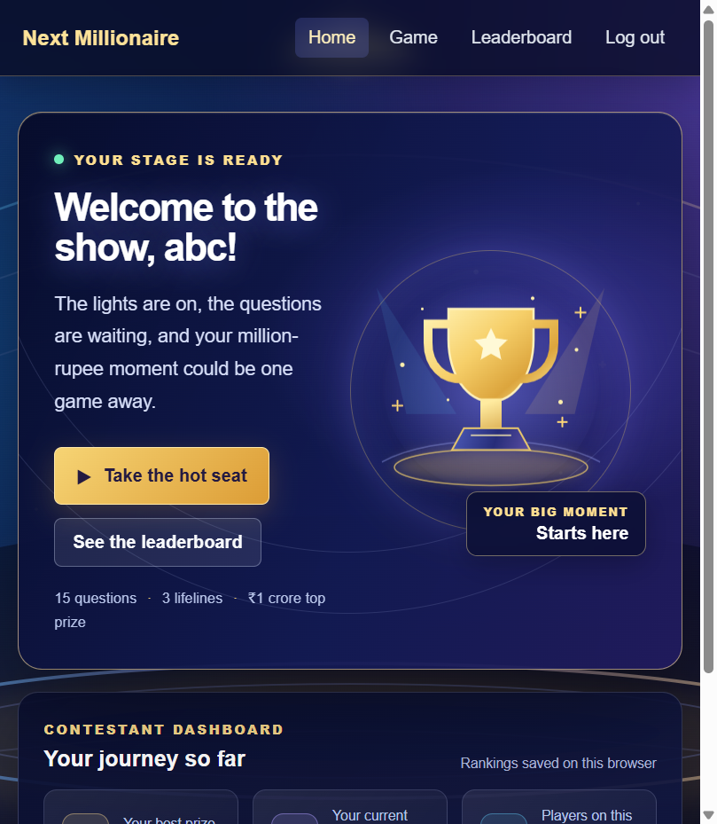

Website Output: Game Page
The game page shows the sound control, quiz introduction, game rules, and the Start game button.
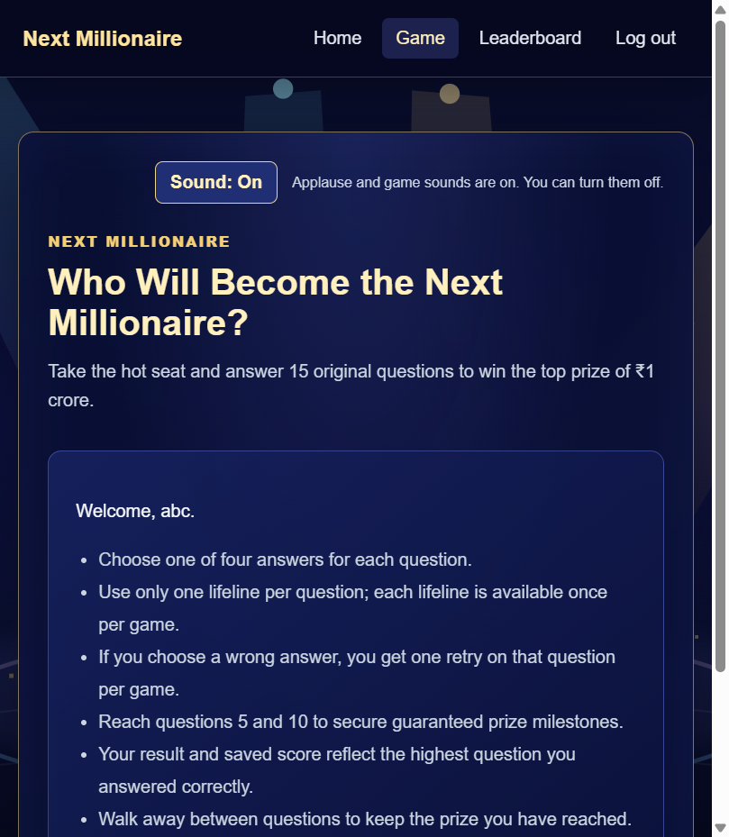

Website Output: Login Page
The login page lets a player enter the email and password used for the browser-only demo account.
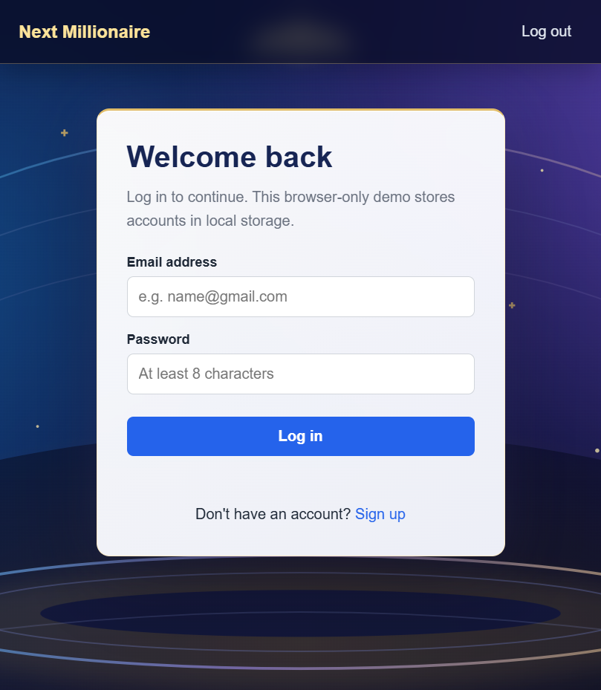

Website Output: Leaderboard
The leaderboard displays the player list and each player?s best prize saved in this browser.
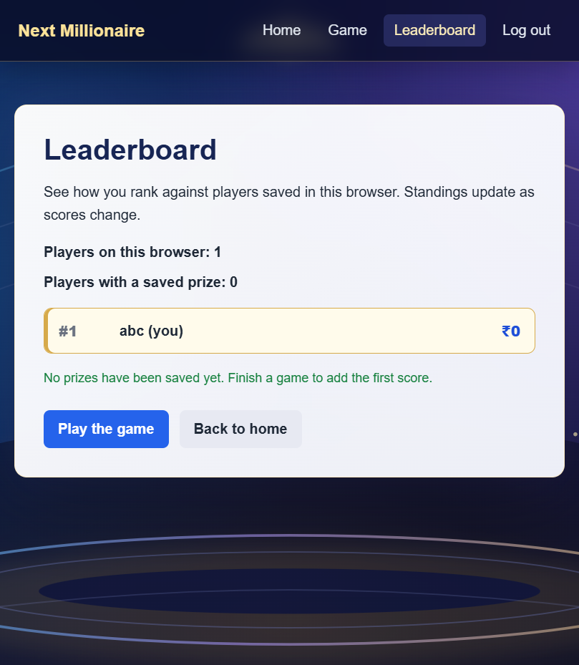

6. Checks and Results
- JavaScript syntax checks passed for the project scripts.
- The question data contains 15 rounds and 60 questions. The answer options and answer indexes were checked.
- The pages and JavaScript module files loaded from the local web server.
- The game page was opened in the browser and showed no JavaScript console errors during the page-load check.

Important Note
This is a learning project, not a real online service. Accounts and scores are stored only in the current browser. Passwords are not protected like they would be on a real website, so do not use a real password or personal information.

Conclusion
This project brings together page navigation, a quiz, lifelines, score saving, a leaderboard, and sound effects. Using small JavaScript modules makes the project easier to understand and gives a clear place to make future changes.

